MINI PROJECT FOR OBJECT ORIENTED PROGRAMING IN C++
NAME:NITHISHKUMAR T
DEPARTMENT:2nd-CSE
TEAM MEMBERS
1.NITHISHKUMAR T
2.PIRVEEN SS
3.ISAAC BIJO MENACHERY
4. MOHAMMED FAIZAL

5. Polynomial Evaluation using Horner’s Method
- Concepts used: Loops, arrays, optimization
- Formula:
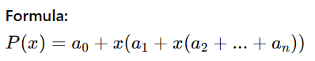
Description: Efficiently compute polynomial values without using pow() repeatedly.
